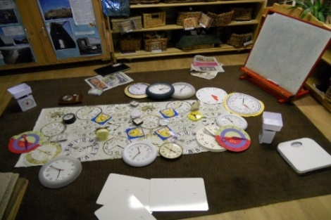
Building on successful mathematics research groups in Bristol over the last two years, we are delighted to be able to offer this professional development to Teachers in settings working with children 3 – 8 years.
FREE CPD for Early Years Teachers
(for teachers working with children 3 – 8 years)
Lunch is provided for the first session
Lunch will be provided on full day

Through this work group, teachers have ‘opened’ up mathematics and taken a lead role in research.
The impact on the school has been:
- Children’s increased confidence with Mathematical thinking.
- Teachers empowered to foster a love of Mathematics.
- Teachers take a lead with their professional development in Mathematics.
- Teachers have been able to lead innovative Mathematical practice in their own settings.
The aims of this work group are to:
- Extend teachers knowledge about how young children learn Mathematics which will enrich and deepen their pedagogy.
- Support teachers in their understanding of how to support children's Mathematics.
- To develop a growth mindset and open approach.
- To develop creative and innovative ways of teaching Mathematics.
To look at how intelligent resources can enrich children’s Mathematical enquiries in the indoor and outdoor environment.

Dates | Venue | Times | Facilitators
Wednesday 23rd January 2019 | Redcliffe Children's Centre  Ship Lane, Redcliffe, Bristol BS1 6RR | 9.00-3.30 pm | Emma Butcher and Jane Redpath - Early Maths Specialists Leaders in Education (SLE)
Wednesday 6th February 2019 | At participant setting,  to be confirmed at first session | 1.00-4.00 pm
Wednesday 20th March 2019 | At participant setting,  to be confirmed at first session | 1.00-4.00 pm
Thursday 9th May 2019 | At participant setting,  to be confirmed at first setting | 4.00-5.30 pm
Cost: The work group is funded by the maths hub programme and is FREE to participating schools. Please note that schools will need to cover their own supply costs, and a non-attendance without notification may carry an administration charge per session missed.
School Commitment: As part of the conditions of booking, the participant's school/setting must have the capacity and commitment to support participants throughout the programme. All participants must be able and willing to commit to participate fully in all elements of the programme.
To book your place on this work group please click Here
Or for further information please e-mail booleanmathshub@clf.cabot.ac.uk

